D424 – Software Engineering
Task 3
Capstone Proposal Project Name: |   FitLog
Student Name: | Svjatoslav Derevyanyy

Table of Contents
Create a professional looking Table of contents that includes your main and subheadings and the related page numbers. Use the automatic TOC generating function of Word or other word processing packages to make the process easier.
The headings that follow are only examples of what might be included. You will need to create headings that are appropriate for your application and process.
Remember that this needs to be a professionally formatted document with detailed information about your project that is easily accessible.

Task 3 Design Document

Class Design
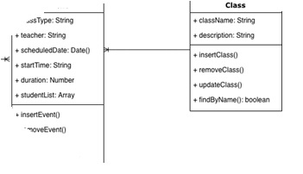
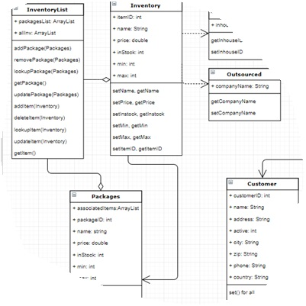
Include images here that relate to the class design(s) that you used for the project. Include an introductory paragraph that describes what’s provided.

UI Design
Include images here of your user interface design. You may include both low and high fidelity. Include an introductory paragraph that describes what’s provided.
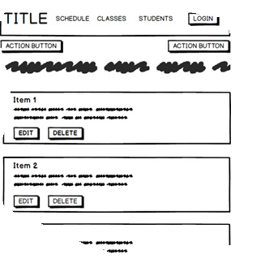
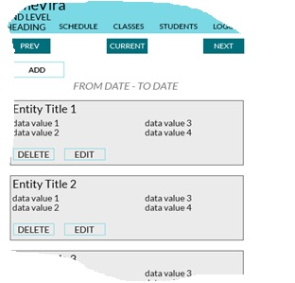
Figure 1: Low Fidelity
Figure 2: High Fidelity

Unit Test Plan

Introduction

Purpose
Provide a brief description of the testing method(s) that you used and what the results it yielded. Also, what remediation was required if necessary and how it would be performed.

Overview
Here you go into more detail about the test(s) and how it related to the overall project. You should include if a similar method was used in other parts of the application or why this was unique for a certain aspect of the code. Then, go into detail about what functions were tested, how the tests were conducted, and how errors were dealt with.

Test Plan

Items
What is required to complete the test(s)?

Features
List the function/features that are part of each test.

Deliverables
List what the test(s) would produce. For example, documentation or code notations.

Tasks
List the tasks required to complete the testing and provide the outcomes you identified.

Needs
Describe what was needed to be running or what support items had to be in place to perform the test? Specify versions if appropriate and other technical requirements. If a testing package and/or library was employed, be sure to identify it/them.

Pass/Fail Criteria
Describe the criteria you used to determine the success of the test and what the protocol was for a positive result. Also describe what the recourse was if the test failed including remediation strategies and documentation requirements.

Specifications
Provide sample code that represents what testing code was used. Screenshots are acceptable.
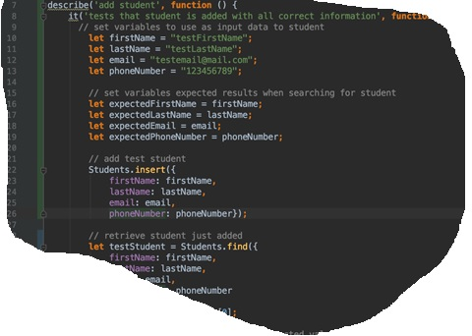

Procedures
Provide a detailed list of the steps you used to complete the testing process. Be sure to mention if iterations were/are part of the process used and when pass/fail results were provided.

Results
Here you will describe and provide examples of the testing results. If you were using a testing package include a screenshot of the interface. Screenshot work best.
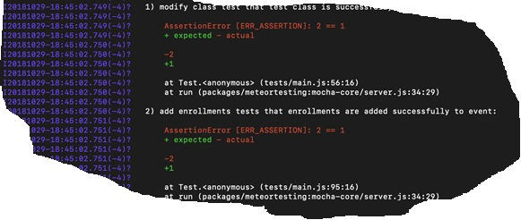

Guide for Setting Up and Maintaining App
Add instructions and documentations needed for accessing the code base, setting up IDE to revise code, and uploading code to the live environment.
. User Guide

Introduction
Provide a description of the content you’re providing in the User Guide. This guide will include how to install, log into, sign up, and use all of the functions of the application. The steps need to be clearly defined and fully tested so the process works flawlessly for the evaluator.

Installation and Using the Application
This procedural information should follow the basic rules of such technical references. While some procedures may provide for personal judgment yours should be clear and concise. Here are other rules to remember:
- Provide step-by-step sequences in the correct order.
- Follow the timing and sequencing of the actual operations.
- Provide visual stepping stones by using bullets or labeling steps.
- Strive to be concise. Avoid lengthy paragraphs but include enough detail so false assumptions are not made.
- Use common terms and jargon appropriate for the audience (someone with basic IT background).
- Explain why steps are completed or what they will yield as well as "How to" instructions.
- Test the instructions to ensure they match the actual product.
- Format the material for ease of reading and use graphic aids to clarify point/steps.
- Write in the present tense and the active voice.

Login and Signup (An example)
- Click the "Log in" button in the top right corner of the app.

- If you already have an account, log in with your account name and password. If you need an account, click on the link below that states “Need an account?”
- If you need to create an account, choose a unique username and password. By default, the password requires at least 6 characters. This function could be changed to address new password requirements.

Classes

Create a New Class
- Once logged in, click on the link at the top labeled “Classes”. This will enable you to create a new class of students.

- Click on “+ Add Class”.
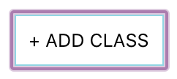
- Enter a class name and its description. The class name must be unique.
- Click “Add Class” to add the class, otherwise click “Cancel” or outside of the modal to cancel adding the class.
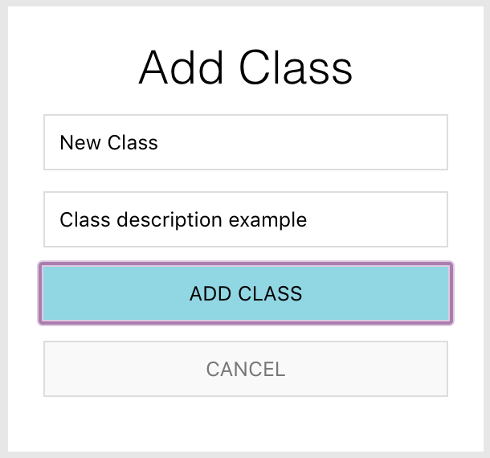

Reports
- To access the reporting feature, from the Schedule module, click on “Generate Report” near the top right of the page.
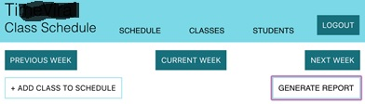
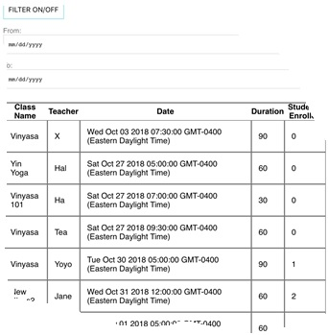
- By default, all events are generated and displayed.

